CD-1000 Single Pocket Discriminator

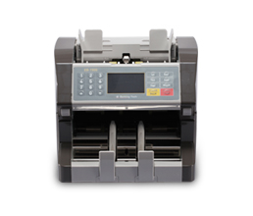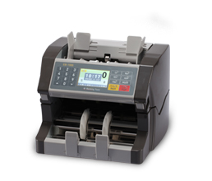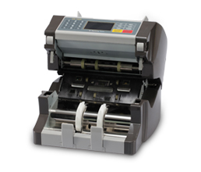

· Single pocket Multi-currency Value counter with CF detection for USD, EUR and Local currencies
· Up to 3 currencies can be installed. Easily open front head for easy maintenance
Specifications
- · ECB Approved
- · Sophisticated counterfeit note detection by UV, FL, MG, MT, IR
- · Value counting for USD, Euro and Local currency with full-size IR CIS
- · Program downloading through RS-232, USB port
- · 3.2” TFT Color LCD display
- · 4 direction (Face, Bottom, Width, Length) note recognition
- · Compact and attractive design
- · Option for 2-line external display or Dual screen display
- · Easily open front head for maintenance
- · Easy trouble-shoot by user from keypad
- · 3D size detection
- · Real Time Clock
- · Recording the counted result
MODEL | CD-1000
Optical Density Detection | O
Double (IR) Detection | O
Size Detection (For Height) | O
Size Detection (For Length) -3D | O
Ultraviolet (UV) & FL Detection | O
Magnetic (MG) Detection | O
Metal Thread (MT) Detection | O
Denomination Value Counting | O
Denomination Detection | Full sized IR CIS
Counting Speed, banknotes / minute | 1000~1500
Display | 3.2〃 TFT Color LCD
Hopper - Input Capacity, banknotes | 300 (500)
Stacker - Output Tray Capacity, banknotes | 200
Dimensions of Banknotes, mm | (m)50X100 / (M)90X180
Digit Display Capacity | 9 digits
Batch Packaging Capacity, banknotes | Max. 999
Connectivity | Serial (RS-232) + USB
Power Consumption, W | AC100-240V, 50/60Hz
Dimensions, mm | 270(w)X278(d)X257(h)
Net Weight, kg | 7.3kg
Warranty, months | 1 year

